**Feature Scaling:**

1. **Normalization:**

from sklearn.preprocessing import MinMaxScaler,StandardScaler

import pandas as pd

from sklearn.model_selection import train_test_split

data = pd.read_csv('Salary.csv')

print("Normalization")

mmscaler = MinMaxScaler()

norm = mmscaler.fit_transform(data)

print(norm)

**Output:**

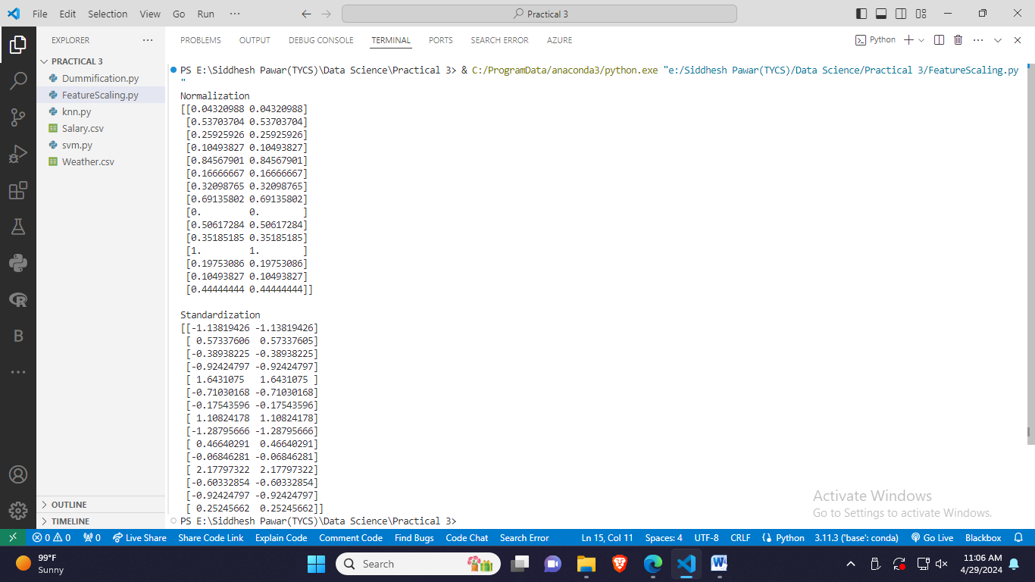

1. **Standardization:**

from sklearn.preprocessing import MinMaxScaler,StandardScaler

import pandas as pd

from sklearn.model_selection import train_test_split

print("Standardization")

stdscaler = StandardScaler()

std = stdscaler.fit_transform(data)

print(std)

**Output:**



**Dummification:**

1. **LabelBinalizer:**

import pandas as pd

from sklearn.preprocessing import LabelBinarizer

data = pd.read_csv('Weather.csv')

df = pd.DataFrame(data)

lb = LabelBinarizer()

lb_result = lb.fit_transform(df['Outlook'])

binalizerdf = pd.DataFrame(lb_result, columns=sorted(list(set(df['Outlook']))))

print(binalizerdf)

**Output:**

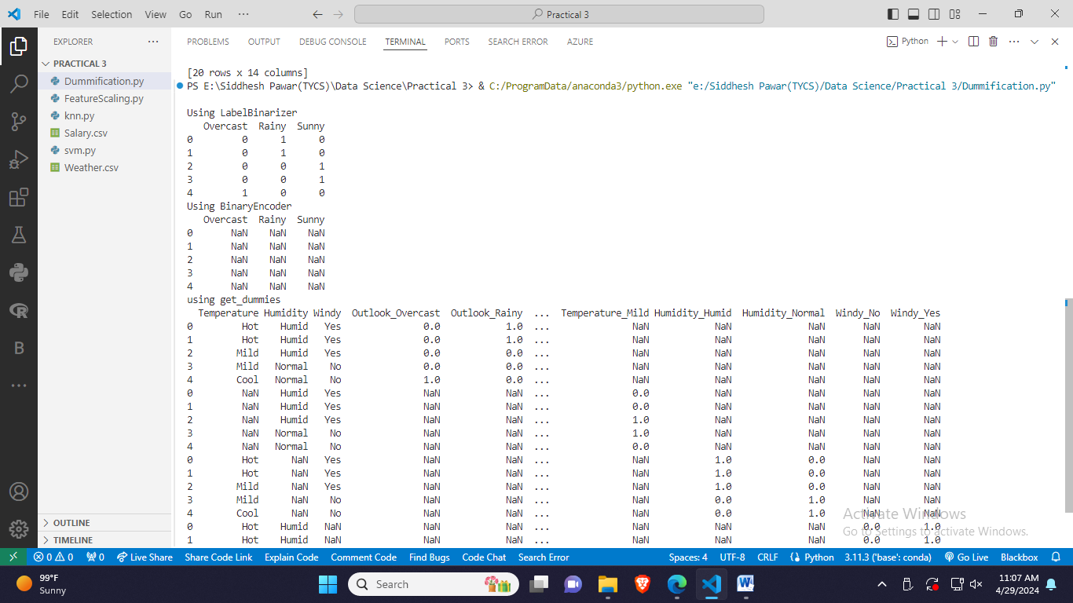

1. **BinaryEncoder:**

from category_encoders import BinaryEncoder

print("Using BinaryEncoder")

bncoder = BinaryEncoder()

bncoder.fit(df['Outlook'])

binalizerdf = pd.DataFrame(bncoder.transform(df['Outlook']), columns=sorted(list(set(df['Outlook']))))

print(binalizerdf)

**Output:**



1. **Get Dummies:**

import pandas as pd

gt = pd.get_dummies(df, columns=['Outlook'])

gt1 = pd.get_dummies(df, columns=['Temperature'])

gt2 = pd.get_dummies(df, columns=['Humidity'])

gt3 = pd.get_dummies(df, columns=['Windy'])

final_df = pd.concat([gt, gt1, gt2, gt3])

print(final_df)

**Output:**

